**Assignment 1**

**NYC Real Estate Analysis using Power BI**

Moiz Deshmukh

12th July 2024

Ms Applied Business Analytics

Boston University, Metropolitan College

**Table of Contents**

Executive Summary 2

Task 1 4

Introduction 4

Task 2 4

Data Analysis in Power BI 4

Task 3 4

Analysing KPIs 4

Task 4 6

Analysing Revenue 6

Task 5 6

Suggestions and Conclusion 6

References 8

Appendix 9

# **Executive Summary**

This report presents a comprehensive analysis of the Bayside neighborhood in Queens, New York City, to support the decision-making process for a real estate brokerage firm considering opening an office in this area. The study involved importing NYC real estate data from a SQL database, followed by a thorough data cleaning process to ensure accuracy and reliability. Power BI was used to conduct the analysis and create visualizations, which helped establish relationships among various models to form a star schema, facilitating a detailed examination of the residential property market in Bayside.

The analysis focused on the total volume of residential sales in 2021, revealing a strong performance with 850 transactions. Despite a slight dip in 2019, likely due to the COVID-19 pandemic (Cohen et al., 2022), Bayside exhibited resilience with a sharp recovery in 2020 and 2021. Compared to other neighborhoods in Queens, Bayside ranked fourth in terms of total sale price, further highlighting its market strength. The neighborhood's stability during economic downturns and its significant revenue potential, estimated at $4.41 million in 2021, demonstrate its attractiveness for real estate investment.

To further assess Bayside’s future growth potential, a forecast analysis using Power BI was conducted. The forecast indicates a continued upward trajectory in sale prices, suggesting steady market growth in the coming years. The confidence interval included in the forecast accounts for potential fluctuations, yet the overall trend remains positive. This analysis supports the conclusion that Bayside is a stable and promising market, making it a viable and profitable area for real estate company investment.

# **Task 1**

## **Introduction**

In this assignment, I have been assigned with the neighbourhood called ‘Bayside’. This neighborhood falls under the Queens borough of the New York City (NYC).

# **Task 2**

## **Data Analysis in Power BI**

The NYC Real Estate data was imported from the SQL database server called metsql.database.windows.net. Before loading this data, a data cleaning process was performed through the ‘transform data’ feature. In this process, the values which were having illogical numbers were either removed or imputed with average values. For example, under the NYC transaction data, the Sale price in a few rows were $0, $10, $100, $500 and $1000. These sale price figures seemed unrealistic for the market of NYC, hence were removed.

Post cleaning process, the data was loaded and then the relationships among the models were created as seen in figure 1. The NYC_Transaction_Data model and the Neighborhood models were connected by creating a connection of their Neighborhood ID tables. Similarly, Borough ID tables were connected from the Neighborhood model and Borough model. The relationship between Building_Class and the NYC_Transaction_Data was established connecting their Building Code ID tables. In this way, all the models were connected directly or indirectly with each other, forming a star schema.

# **Task 3**

## **Analysing KPIs**

To calculate the total volume of residential sales in the last year (2021), several filters were applied like the ‘Neighborhood’ filter which enabled the observation of only Bayside’s data. Similarly, the ‘Type of property’ filter was applied to observe only the residential property’s data. Additionally, the filter of ‘Sales_Date’ was applied to observe the data only from the last year, 2021. As seen in the figure 2, on applying these filters, the total volume of residential sales in the Bayside area appeared to be 850. This figure was expressed in counts.

The analysis of past 5 years market performance of the residential properties in the Bayside neighborhood was made. As the figure 3 depicts, the Bayside neighborhood had a descent sales volume in year 2017 and 2018, however, there was a dip in the sale price during the year 2019 and 2020. This could possibly be due to the pandemic COVID-19 and its affect over the real estate market across the USA. The figure 4 containing the historical data table is also prepared to support this analysis. Interestingly, in both the bar chart (figure 3) and table (figure 4), we can see a sudden spike in the sale price in 2021. This depicts an aggressive buying behaviour of customers in the real estate industry and is also a positive indicator for investing in the real estate business.

To gain deeper insights, additional KPI’s were analysed. The figure 5 shows the volume of sales by borough name. This shows how each borough is performing in the NYC. The neighborhood, Bayside, which I have been assigned is, falls under the Queens borough. The Queens borough has the 3rd highest total sales compared to the other boroughs, with a total sales accounting 185 billion dollars.

By analyzing the neighborhood data of Queens borough in greater detail, it was observed, as shown in Figure 6, that Bayside ranked as the 4th best-performing neighborhood in terms of total sale price of residential properties. An interesting observation is that during 2019 and 2020, when the entire real estate market was declining and many neighborhoods in Queens experienced a downturn, Bayside was not heavily impacted by the COVID-19 effect, as indicated in Figure 6. The trend suggests that Bayside's residential properties’ market remained quite stable during those two years, unlike other neighborhoods such as Long Island and Astoria, which saw a sudden dip during that period.

The line chart in Figure 7 clearly illustrates an upward trend in the market for Bayside’s residential properties. From 2017 to 2021, we observe a steady increase in the sum of sale prices, with a notable dip in 2019 followed by a sharp recovery in 2020 and 2021. This trend underscores Bayside's stability and growth potential compared to other neighborhoods.

# **Task 4**

## **Analysing Revenue**

Considering the condition that the real estate companies, on average, earn a commission of 5 cents per dollar on residential sales and the market penetration in my neighborhood, Bayside, is 12.5%, a new column called revenue was created. Basically, the total sales price was multiplied by the commission and the market penetration. The DAX used to create this column was *Revenue = NYC_TRANSACTION_DATA[SALE_PRICE]*.05*.125*

The figure 8 in the appendix shows that the total revenue our company would have earned last year (2021) was USD 4.41 million on the sales of residential properties in the Bayside neighborhood.

# **Task 5**

## **Suggestions and Conclusion**

The analysis of the NYC real estate market, particularly focusing on the Bayside neighborhood in Queens, reveals several important insights. Historically, the overall market has experienced fluctuating trends in sale prices from 2003 to 2023. There were significant dips around 2009 and during the 2020 pandemic period, reflecting broader economic downturns. However, a notable recovery and upward trend post-2020 indicate a positive market rebound, showcasing the resilience and adaptability of the NYC real estate sector. Bayside, in contrast, has shown a stable and promising market performance over the past five years, with a sharp recovery in 2020 and 2021, indicating strong buyer interest and sustained market activity.

Bayside’s stability during the COVID-19 pandemic is particularly noteworthy. While many neighborhoods in Queens experienced significant downturns, Bayside remained relatively unaffected. This stability is a significant indicator of the neighborhood's resilience and attractiveness to potential buyers and investors. Compared to other neighborhoods in Queens, Bayside ranks fourth in terms of total sale price, further emphasizing its strength in the residential real estate market. The strong performance of the Queens borough, with $185 billion in total sales, and Bayside’s notable ranking within it, underscore the neighborhood’s potential for future growth and investment. The revenue potential for real estate companies operating in Bayside is substantial. With an average commission of 5% on sales and a market penetration rate of 12.5%, the estimated revenue in 2021 was $4.41 million. This figure highlights the lucrative opportunities for real estate firms in the Bayside area, making it an attractive market for sustained business activities.

To assess the future growth potential of the Bayside market, I also performed a forecast analysis using POWER BI as seen in Figure 9. The forecast chart indicates a continued upward trajectory in sale prices, suggesting that Bayside's market will likely experience steady growth in the coming years. The forecast includes a confidence interval that accounts for potential fluctuations, yet the overall trend remains positive.

Additionally, the analysis of ZIP code data (in figure 10) shows that the Bayside area with ZIP code 11361 has the highest sales potential for residential properties, making it an ideal location to set up a real estate office. In terms of property types, "Two Stories - Detached SM or MID" generated the highest revenue from previous sales records (see figure 11), highlighting a lucrative opportunity for specializing in this property type.

All this analysis reinforces the idea that Bayside is not only resilient but also poised for future expansion, making it a viable and profitable area for a real estate company investment. While it is essential to remain vigilant of potential economic uncertainties, the optimistic outlook for Bayside underscores its attractiveness for sustained investment and revenue generation.

# **References**

Cohen, J. P., Friedt, F. L., & Lautier, J. P. (2022). The impact of the Coronavirus pandemic on New York City real estate: First evidence. Journal of Regional Science, 62(3), 858–888. https://doi.org/10.1111/jors.12591

# **Appendix**

**Figure 1**

*Establishing relationships between the models*

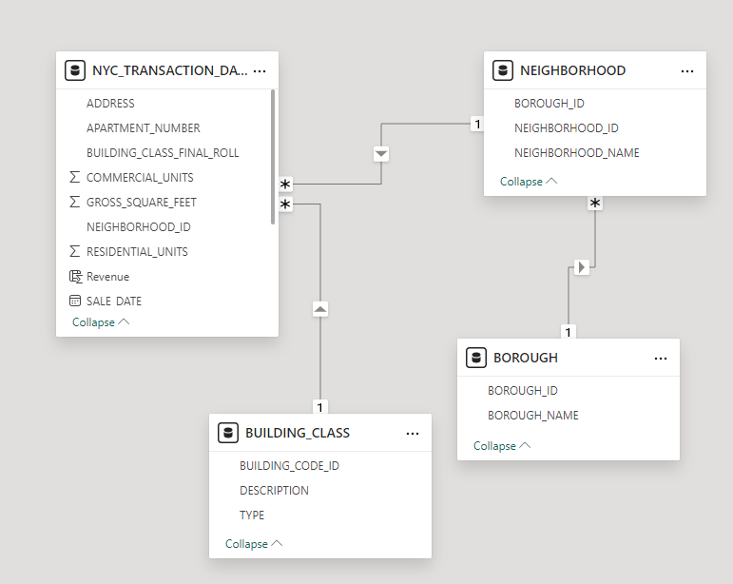

**Figure 2**

*Sale Count from last year (2021) in Bayside Neighborhood*

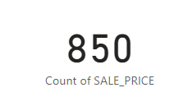

**Figure 3**

*Market performance over past 5 years of residential properties in Bayside neighborhood*

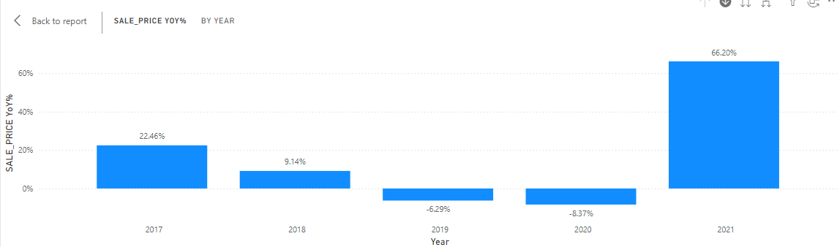

**Figure 4**

*Historical Data table on YoY market performance of residential properties in Bayside neighborhood*

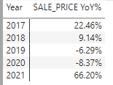

**Figure 5**

*Volume of sale by Borough name*

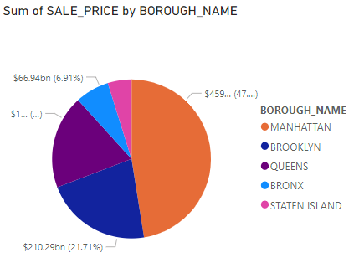

**Figure 6**

*Sum of Sale Price of Residential Properties by year and neighborhood name*

*(Note: - The purple line highlights the Bayside’s data)*

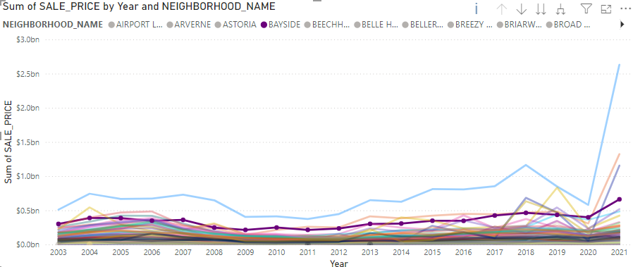

**Figure 7**

*5 years’ sum of sales price of Bayside’s residential properties*

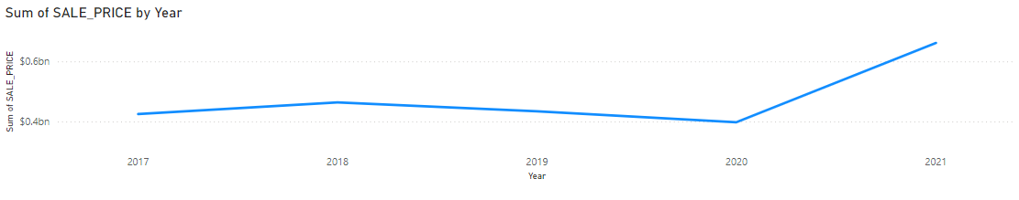

**Figure 8**

*Total revenue earned last year (2021) in the Bayside Neighborhood on the sales of Residential Properties.*

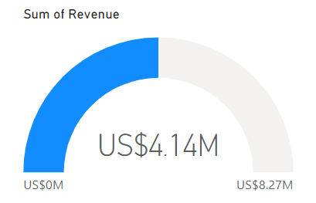

**Figure 9**

*Future Sales forecast of residential properties in Bayside neighborhood*

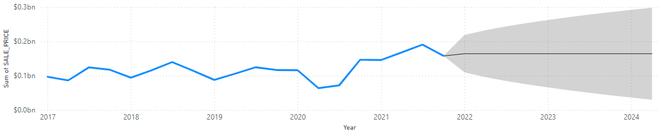

**Figure 10**

*%GT Sum of Sale Price by Zip Code*

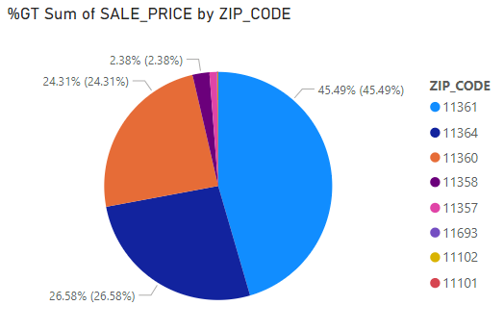

**Figure 11**

*Historical Data table for revenue generated as per description of residential properties*

